Course Number | EES 604
Course Title | Electronics and Sensors
Semester/Year
Instructor

Lab Report# 6
Lab Title
Lab Date
Lab Section
TA’s Name

Student Name | Student ID | Signature

*By signing above you attest that you have contributed to this written lab report and confirm that all work you have contributed to this lab report is your own work. Any suspicion of copying or plagiarism in this work will result in an investigation of Academic Misconduct and may result in a “0” on the work, an “F” in the course, or possibly more severe penalties, as well as a Disciplinary Notice on your academic record under the Student Code of Academic Conduct, which can be found online at: www.ryerson.ca/senate/current/pol60.pdf.

LAB INSTRUCTIONS
LAB 6: OP- AMP and SENSORS APPLICATIONS
EES604 (Electronics & Sensors)
Revised by Sattar Hussain © Ryerson University 2019

Objectives: | - To gain experience in the use of basic electronic instruments, and to investigate some basic linear OP-AMP circuits, specifically, difference amplifiers.  - To understand the basic of sensors principles and the operation of different sensors with accessory circuits.
Equipment: | 2-Channel Oscilloscope, Dual DC Power Supply, and Digital Multi-Meter.
References: | Main and reference textbooks, lecture notes, and OP-AMP and sensors data sheets.

PRE-LAB Assignment:
- Study the datasheet of the load cell (strain gauges in a whetstone bridge) FSH00889 and compute the output of the load cell in mV for a load of 226.8 grams if the excitation voltage is 9 V DC.
- Study the data sheet of the instrumentation amplifier AD620 and calculate the value of “RG” that controls the gain of the AD620 in Figure 1 such that the load cell output for 0 to 1 lb is mapped to 0 to +V (< +9V) or –V (< -9V) of the amplifier .
Note: from the datasheet, the nominal rated output of load cell is specified in terms of mV output per one volt of the excitation at full load (capacity). The load cells are a bridge and the mV/V rating is used to quantify the output at any given excitation. For different loads (weights), assume the output is changing linearly with the applied load.
- Design the single-sensor Whetstone bridge circuit shown in Figure 2. The bridge will be used to study one of the widely used sensors, the Thermistor. You are required to study the data sheets of these sensors and then calculate the values of “R”, “R1”, and “R2” so that the bridge is balanced at room temperature (about 25ᴼ C). Use a 9-V supply for your design calculations.
Notes:
- Visit http://www.ee.ryerson.ca/~jkoch/courses/bme674/bme_674.html for datasheets of the components that will be used in this lab.
- Please note your design should consider the safe operating limits of all the components in the circuits.
- The pre-lab exercise should include detailed analysis, design approach, and justification of component choices.
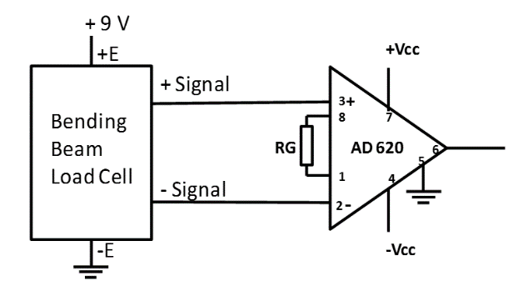

Figure 1: Cascading AD620 to a Load cell with strain gauges in a whetstone bridge

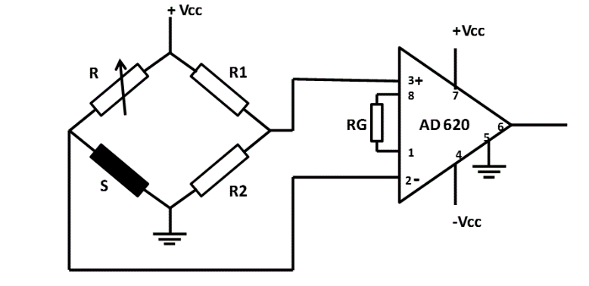

Figure 2: Single-sensor (Thermistor) Wheatstone bridge-AD620 circuit

EXPERIMENTS AND RESULTS
1) Strain Gauge: Displacement to Voltage:
Build the circuit shown in Figure 1. Use the value of RG calculated in pre-lab part (P2). Use DC power supply for +Vcc (+9V), –Vcc (-9V) and +9-V excitation source for the load cell. Using pre-set weights provided to you, measure the output of the difference amplifier for 4 different weights and record them in Table 1.
Record below the following values:
RG =
Amplifier Gain =
Measured Dynamic Range of the sensor =
Measured output range of the amplifier =
Table 1
Load Cell | Input (g) | Output (V)
1
2
3
4

Plot input versus output characteristics of the strain gauges bridge. Use the obtained graph to compute the sensitivity of the sensor. Use excel or Microsoft word to sketch you graph.

Sensitivity of the sensor =

Figure 3: Strain gauges bridge I/O characteristics

2) Thermistor: Heat to Voltage:
Build the circuit shown in Figure 2 (“S” is the sensor under study). Use the calculated value in pre-lab part (P3) (thermistor resistance) to choose the values for the resistors. Note that the Amplifier Gain is now 2.5. Borrow the heater and the thermometer from your TA. Using different output settings of the heater and varying the distance between the heater and the thermistor, record the amplifier output in Table 2 for 4 different temperatures (25– 50ᴼ C) in the vicinity of the thermistor. It is recommended that you heat to the maximum temperature and record the output values as the temperature is returning back to room temperature.
Record below the value of each of the following:
R =
R1 =
R2 =
RG =
Amplifier Gain = 2.5
Dynamic Range of the sensor (limited to your 5 different temperature settings) =
Mapped output of the amplifier =
Table 2
Thermistor | Input (degree C) | Output (V)
1 | 25 (room temp.)
2
3
4

Plot input versus output characteristics of the Thermistor sensor. Use the obtained graph to compute the sensitivity of the sensor.

Sensitivity of the sensor =

Figure 4: Thermistor I/O characteristic

CONCLUSIONS AND REMARKS
- Discuss your pre-lab design analysis, specifications, and the observed results. Comment if there were any deviations.

- Comment on the linearity and sensitivity of your sensor measurements.

- Provide an example application for each of the sensors experimented in this lab.

